**CSDA 1050 Sprint 1**

**July 29, 2019**

**Nickolas Lal**

**Overview:** This project looks at trying to identify the marginal difference in rent price between tenured renters and new renters in Toronto. After the completion of Sprint 1 the scope has been narrowed further by focusing specifically on years 2013-2017 as this is where the data was available. Sprint 1 is the first phase of acting on the proposal and represents data collection and exploration phase. Here preliminary insights are drawn while deeper analysis takes place in the future sprints.

**Data collection and cleaning:**

**Toronto Income data from 2013-2017**- The below Statistics Canada link includes income of individuals in 2017 constant dollars from 2013-2017. There are options to filter the data by age group, sex, income source and by geographic location including Canada and provinces and selected census metropolitan areas. It was filtered for total income of all residents ages 16 and over in Toronto. The dataset was then further cleaned to only include the necessary information which is the average and median income per year.

<https://www150.statcan.gc.ca/t1/tbl1/en/tv.action?pid=1110023901&pickMembers%5B0%5D=1.17&pickMembers%5B1%5D=2.1&pickMembers%5B2%5D=3.1&pickMembers%5B3%5D=4.1>

**Annual Inflation:** The annual inflation rate in Canada, comparing year over year, December to December, from 1984-2018 was taken from the below. It was then input into a CSV file so it could be used for analysis.

<https://www.inflation.eu/inflation-rates/canada/historic-inflation/cpi-inflation-canada.aspx>

**Ontario rent increase guidelines-** The full details on how the law and calculation works along with the historical numbers dating back to 1991 was available on the below government of Ontario website. It was then combined with the inflation numbers, starting from 1991, and then input into a CSV file so it could be used for analysis.

<https://www.ontario.ca/page/rent-increase-guideline>

**Preliminary Exploration and Analysis:** After the data was collected cleaned it was loaded in and ready for exploratory analysis.

City of Toronto boundaries

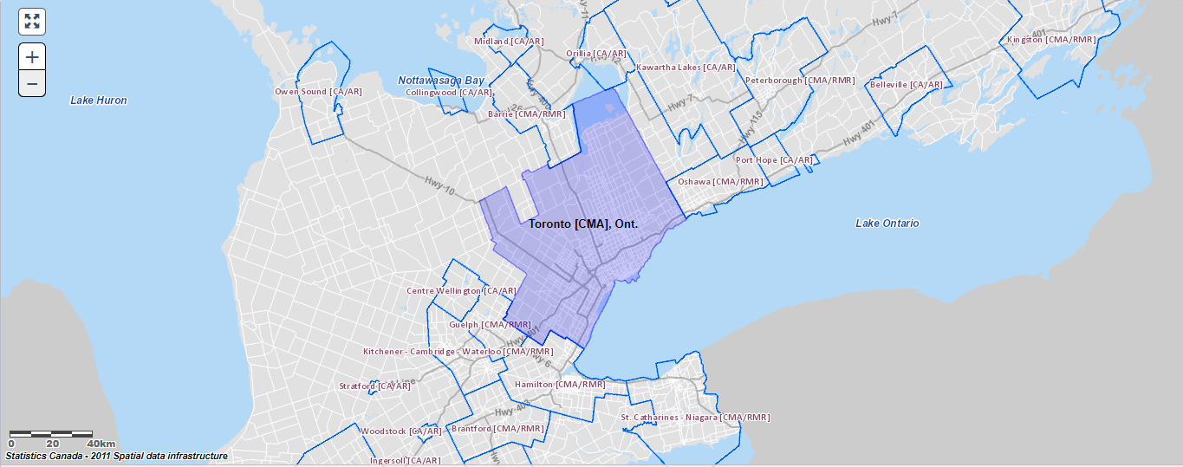

The first graph below compares the Inflation rate with rental increase guidelines. Here we can see that generally the rent increase is always larger than inflation although there have been a few occasions where it was smaller.

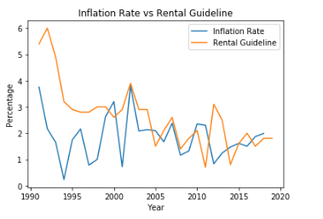

A better visualization of the gap in the rental increase guidelines vs the Inflation rate is displayed by plotting the difference, Guideline-Inflation rate. Here we can better see that the rental guideline rate is usually higher, and occasionally lower or equal to the inflation rate.

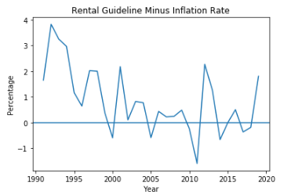

Next we compare the Inflation rate with the change in price in each type of dwelling, starting with the change in the price of Bachelor apartments. Here we can see that the Bachelor change in price is almost always greater than the rate of Inflation aside from a few exceptions where Inflation is equal to or lower than the Bachelor change. We see this at roughly 2002-early 2006, late 2007-2008, and 2009-early 2010.

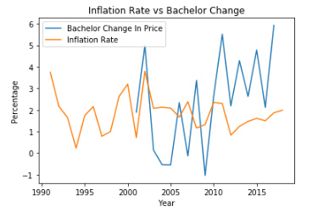

Below we are comparing the Inflation Rate with the change in price of One Bedroom apartments. Here we can see that the Inflation Rate was greater from about 2001-2008 and 2009-2010 and it was smaller otherwise. There is also a sharp increase in the change in price from about 2015 onwards.

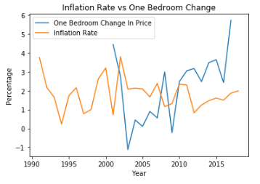

Below we are comparing the Inflation Rate with the change in price of Two-bedroom apartments. Here we can see there were many sharp increases and decreases in the change of price between 2001 and 2010. We can also see the Inflation Rate was greater from about 2001-2008 and 2009-2010 and it was smaller otherwise. There is also a sharp increase in the change in price from about 2015 onwards.

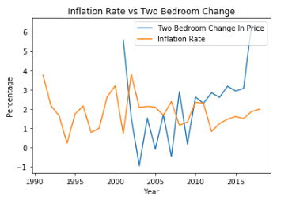

Below we are comparing the Inflation Rate with the change in price of Three-bedroom apartments. Here we can see there were many sharp increases and decreases in the change of price throughout, the biggest being the drop in 2003. Aside from a few exceptions we can see the Inflation Rate was greater or roughly the same from about 2003-2010. Aside from a few exceptions from about 2010 onwards the Inflation rate was smaller.

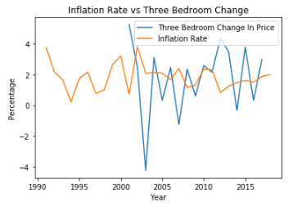

Below we are comparing the Inflation Rate with the change in price of the city average. Here we can see there were some sharp fluctuations in the change of price between 2001 and 2011. We can also see the Inflation Rate was greater from about 2001-2007 and 2009-2010, it was smaller otherwise. There is also a steep increase in the change in price from about 2015 onwards.

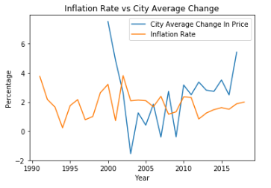

Finally, we are now plotting them all together to compare and get a visual on each individual apartment type alongside the city average, guideline, and inflation.

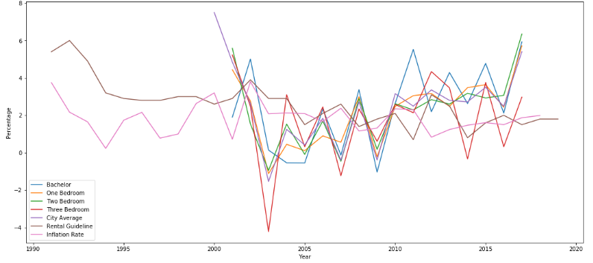

**Next steps:**

* Locate and splice rich historical Toronto rental data
* Further research and deeper analysis